**ESS**

**INTRODUCTION**

Employee Self-Service (ESS) applications are indeed crucial tools for organizations like BPCL, streamlining various administrative tasks for employees. With ESS, BPCL employees can conveniently manage travel claims, request certificates, and even adjust their shifts. This user-friendly interface enhances efficiency and empowers employees to handle these tasks independently, reducing administrative burdens on HR personnel and fostering a more self-reliant work culture. Such applications not only save time but also contribute to better organizational performance by ensuring smoother workflows and greater employee satisfaction.

**LOGIN PAGE:-**

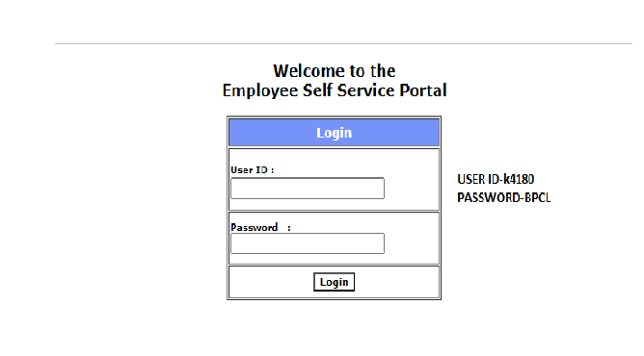

**Home Page of application:-**

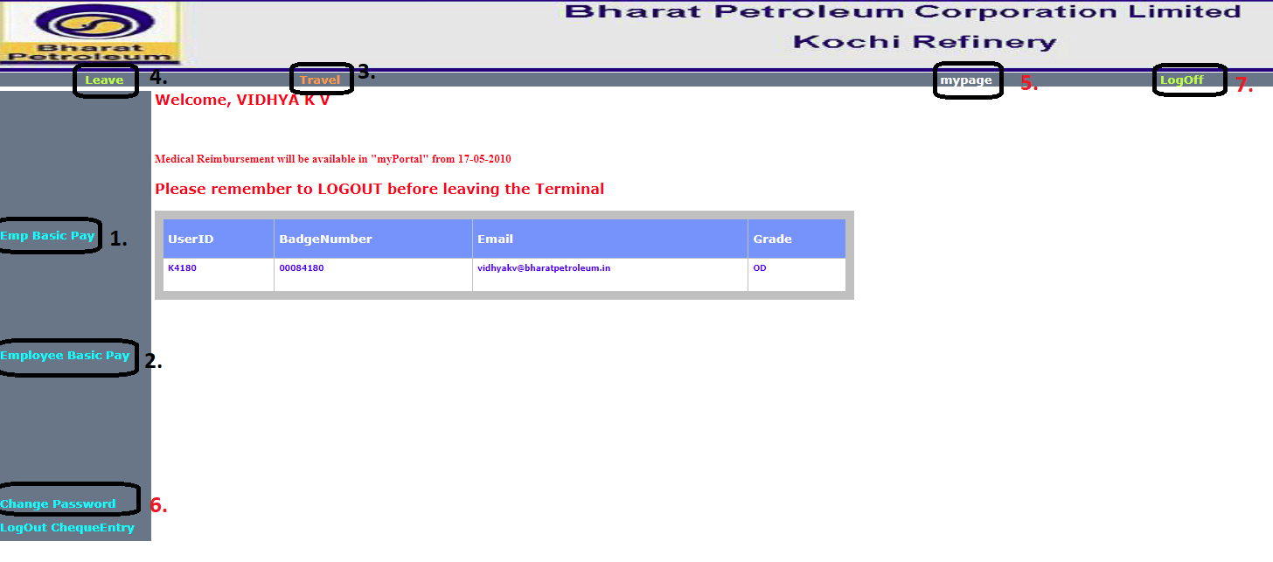

On home page there are many function we can see on given figure.

1. Emp Basic Pay
2. Employee Basic Pay
3. Travel
4. Leave
5. Mypage
6. Change password
7. LogOff

**Emp Basic Pay:-**

In this we can see employee basic pay via click on Emp Basic Pay.

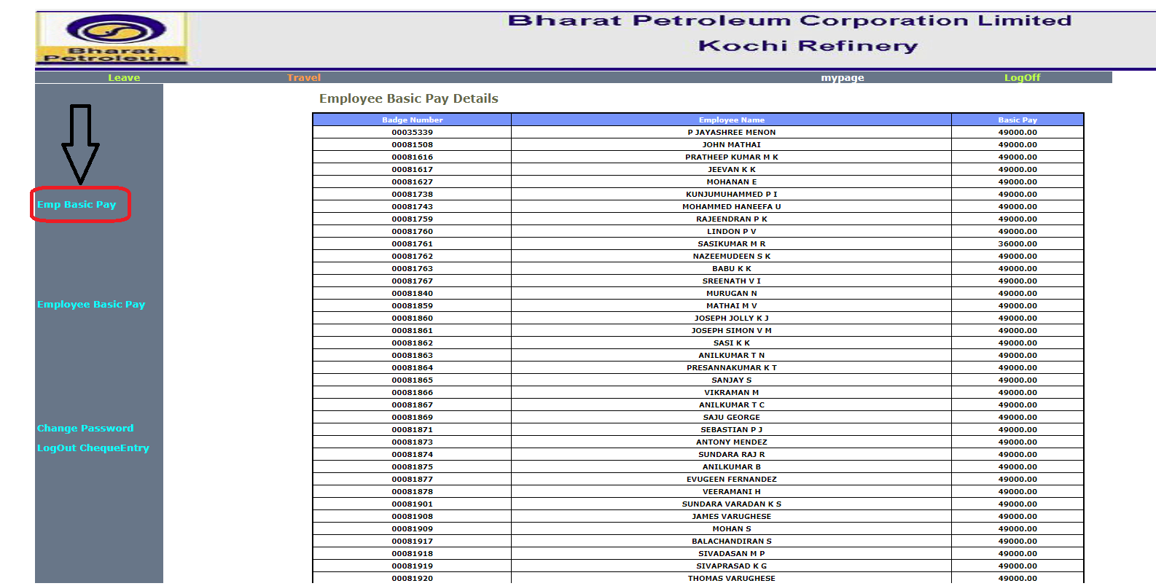

**Travel:-**

After click on Travel a Travel Request form will be open, in that form we have to fill some data that you can see on below figure, after fill the form we have to click on submit ,then a request will generate.

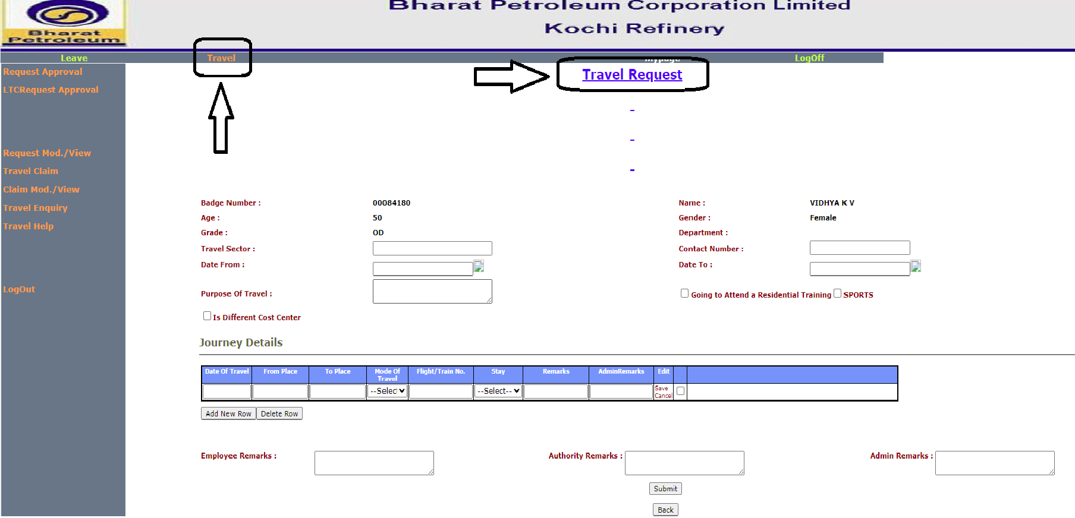

**Request Approval:-**

If we have to check how many travel request are in pending, then we have to click on travel then Request Approval.

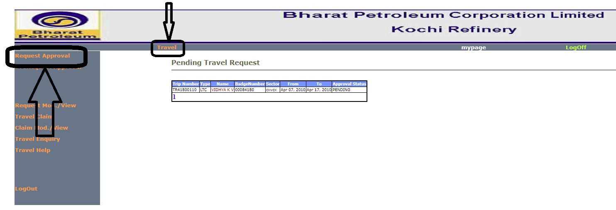

**Request modify/view:-**

**If we have to modify the travel request then we have to click on travel then Request Mod./View then details and we can modify the travel request .**

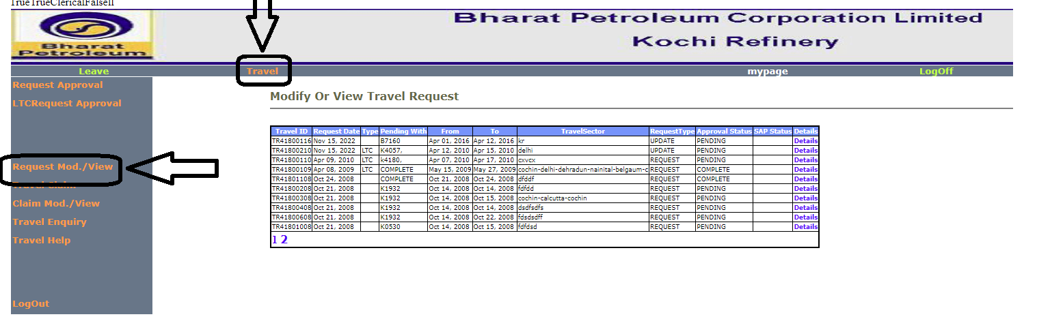

**Travel claim Modify/view:-**

**If we want to travel claim then we have to click on Travel then Claim Mod./view then details then we can modify travel claim.**

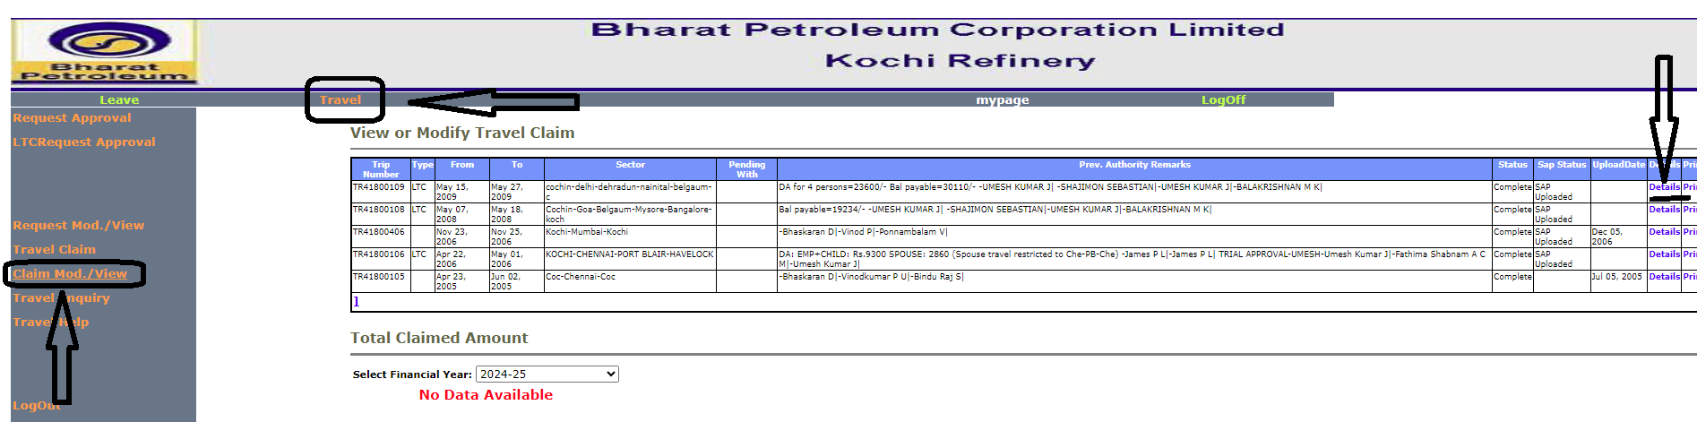

**Travel Enquiry:**

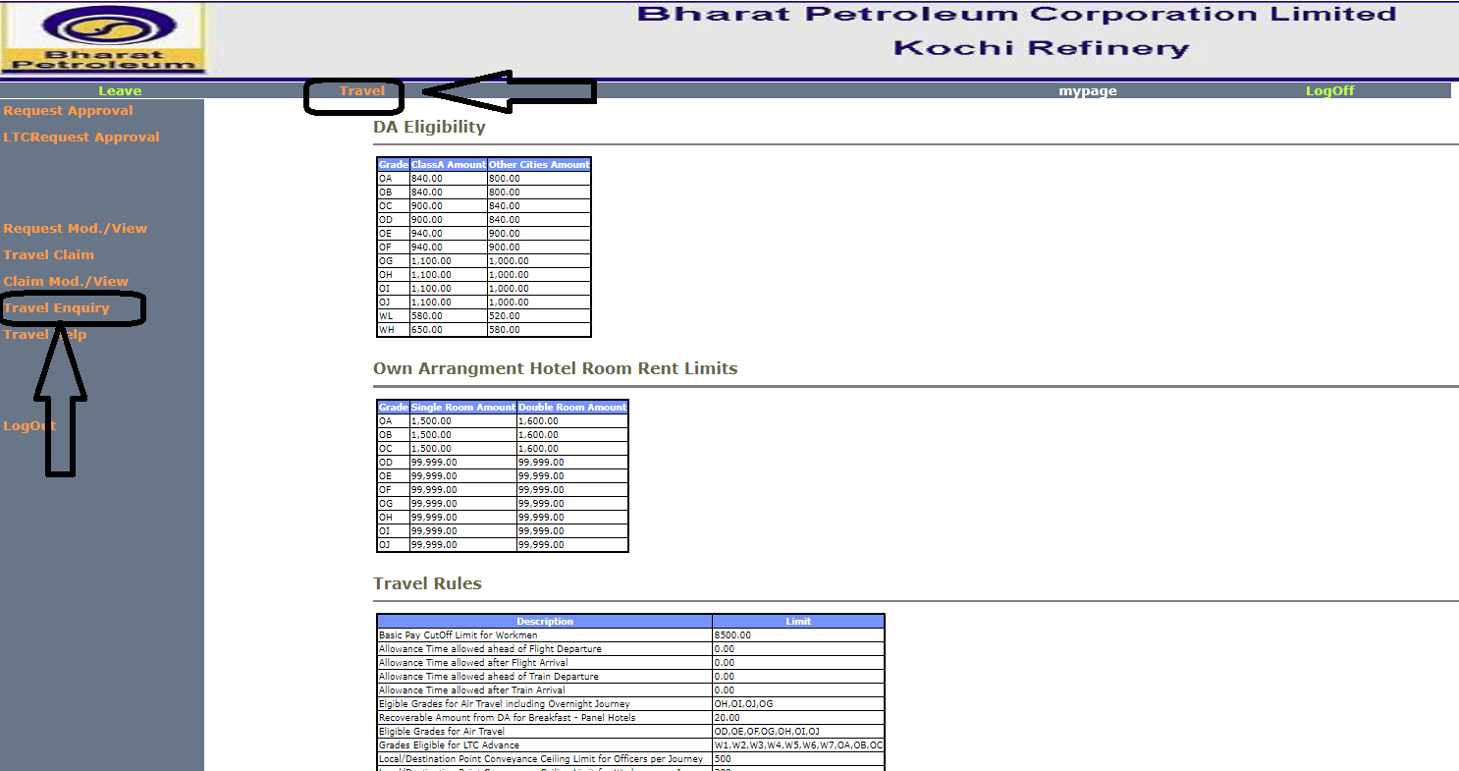

**Shift Recommend/Approve:-**

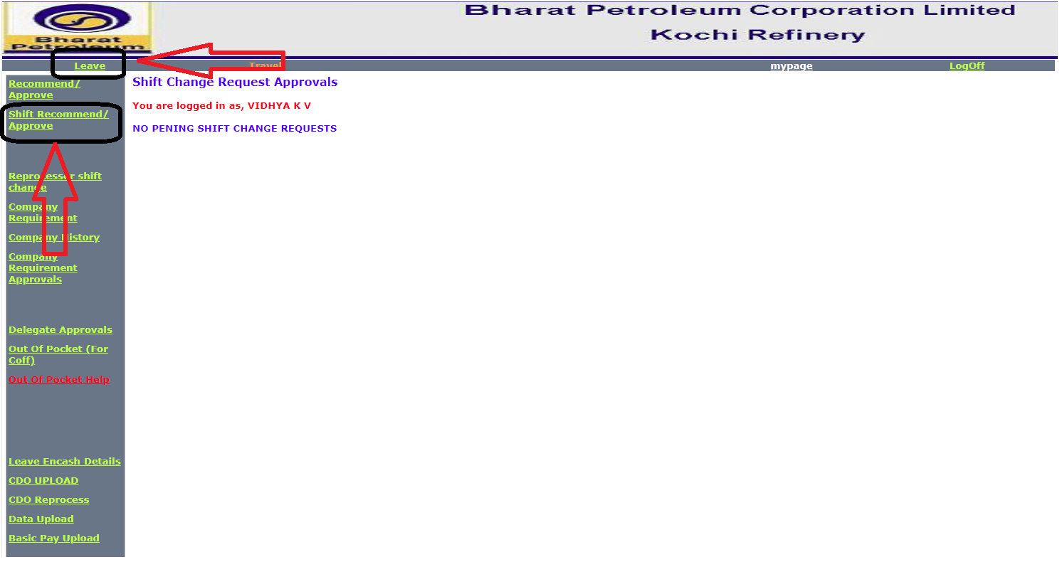

**Reprocessor Shift Change:-**

**If we want to change the shift then we we have click on leave then Reprocessor Shift change then tick the employee and submit.**

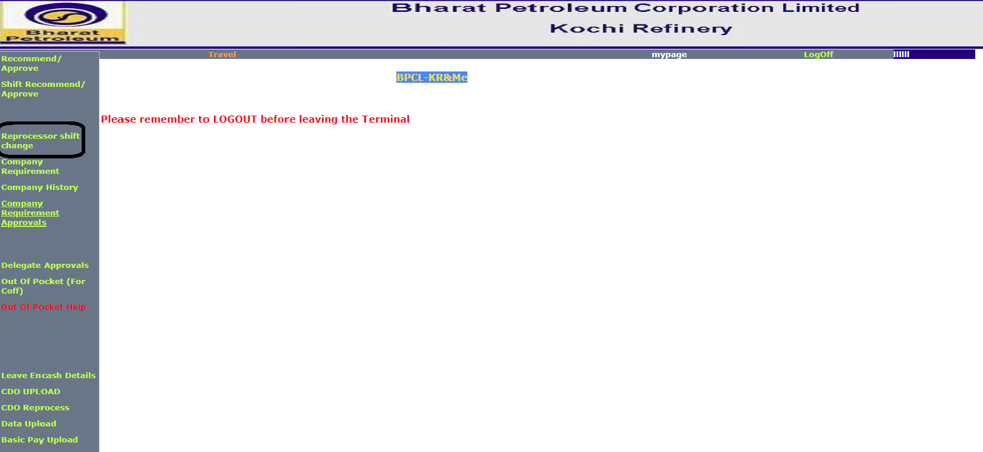

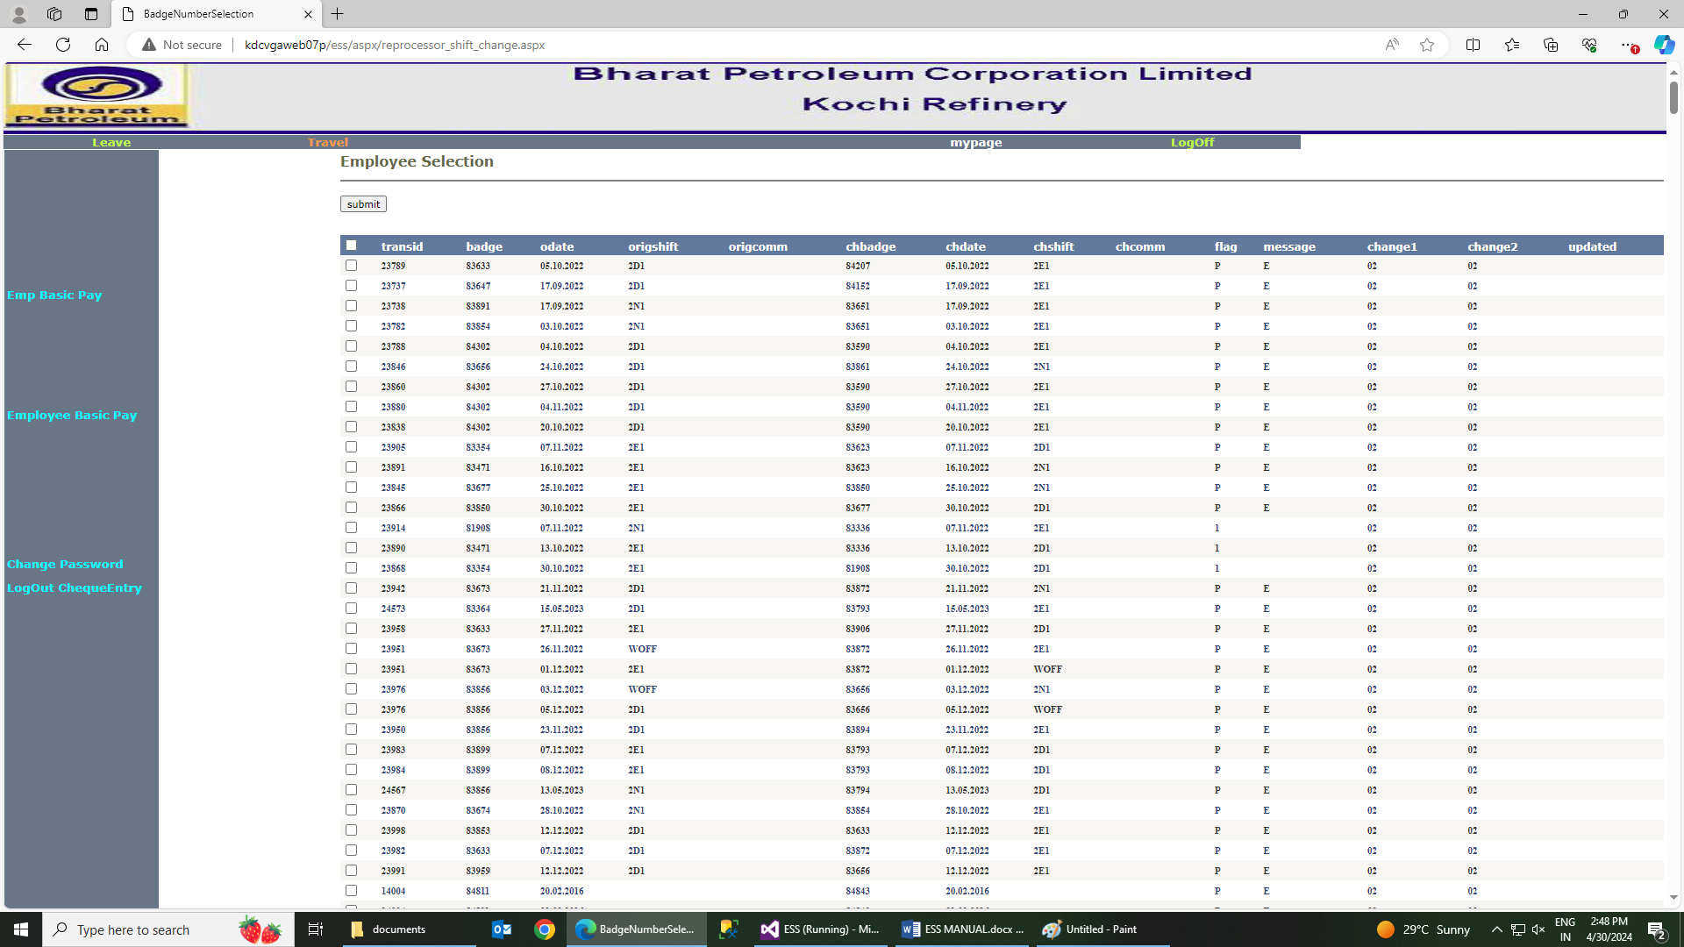

**Company Requirement:-**

**If company required some employee then we have send the request by fill the below form.**

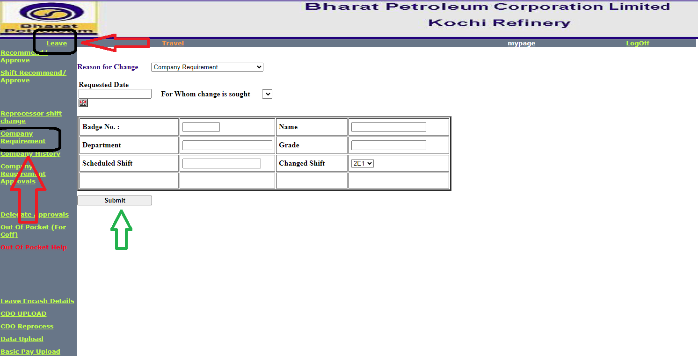

**Company History:-**

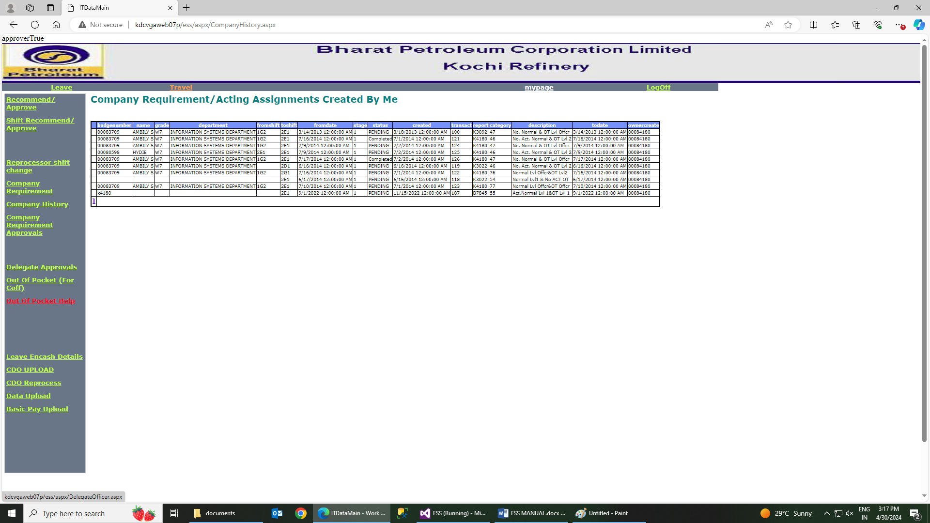

**Company Requirements Approvals:-**

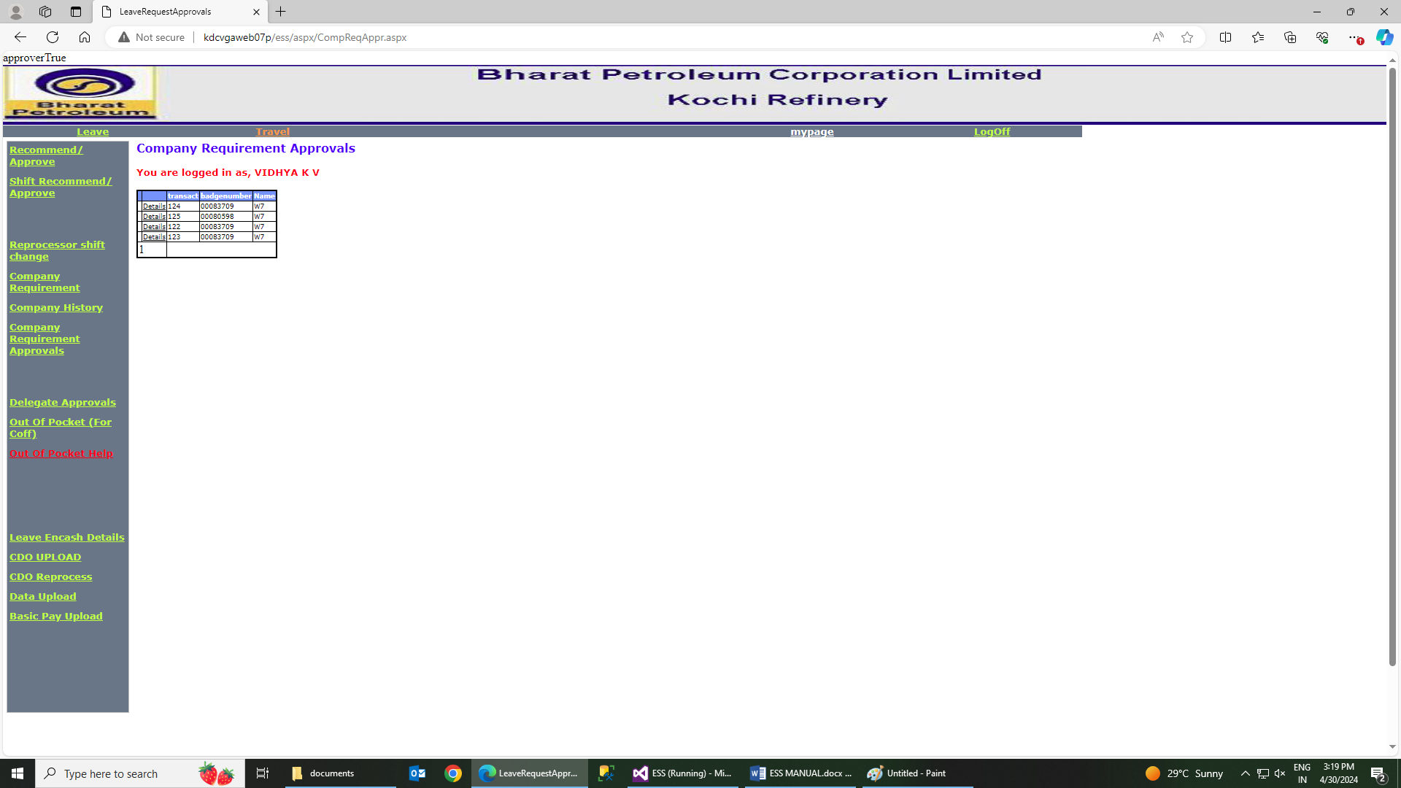

**Delegates Approvals:-**

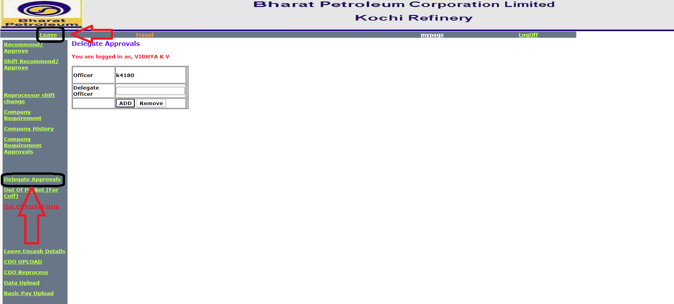

**CDO Upload:-**

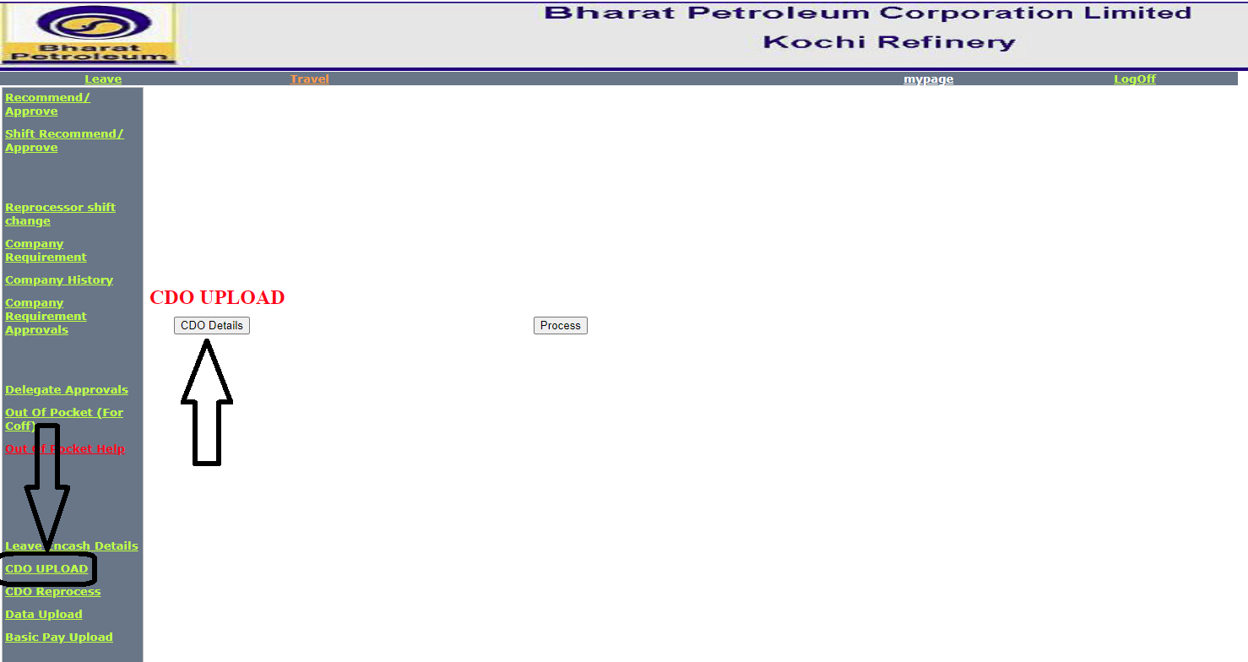

**MyPage:-**

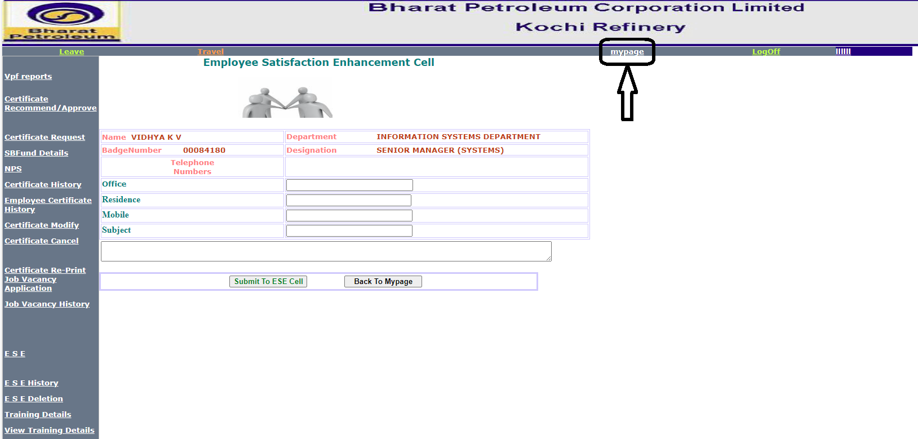

**VPS Reports:-**

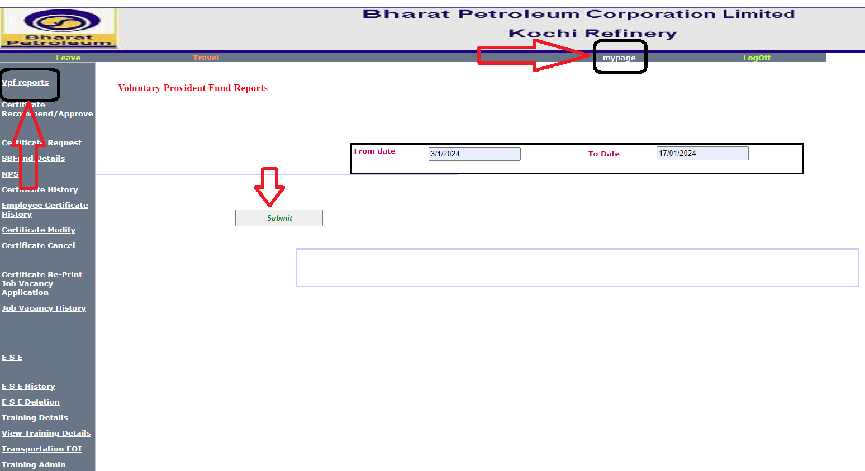

**Certificate Recommend/approve:-**

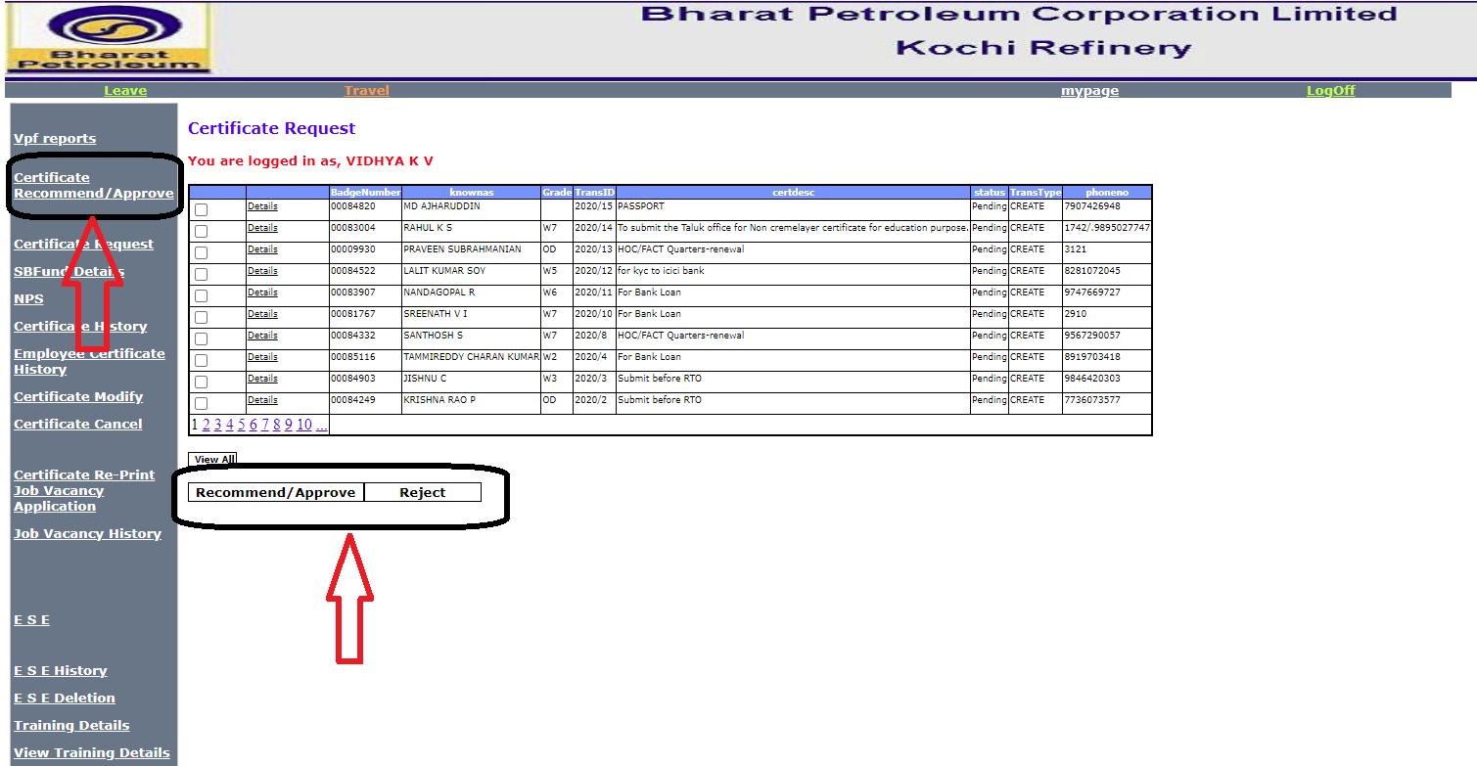

**Certificate Request:-**

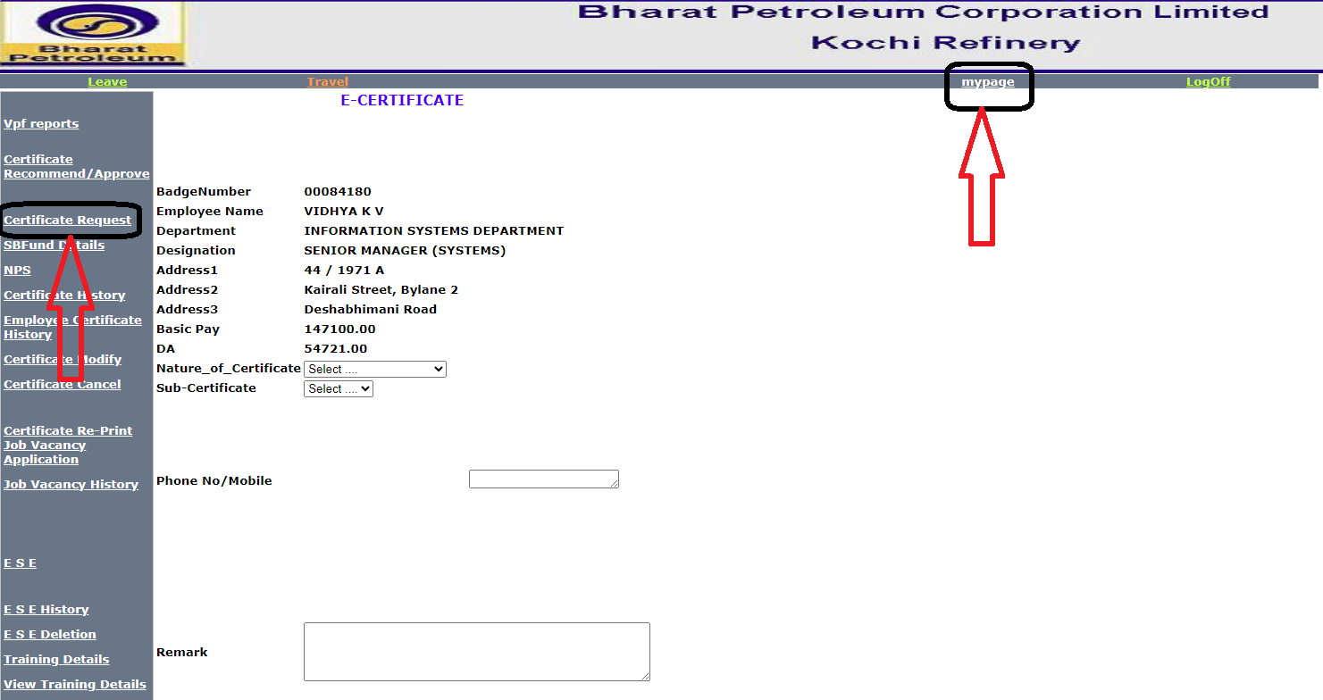

**SBFund Details:-**

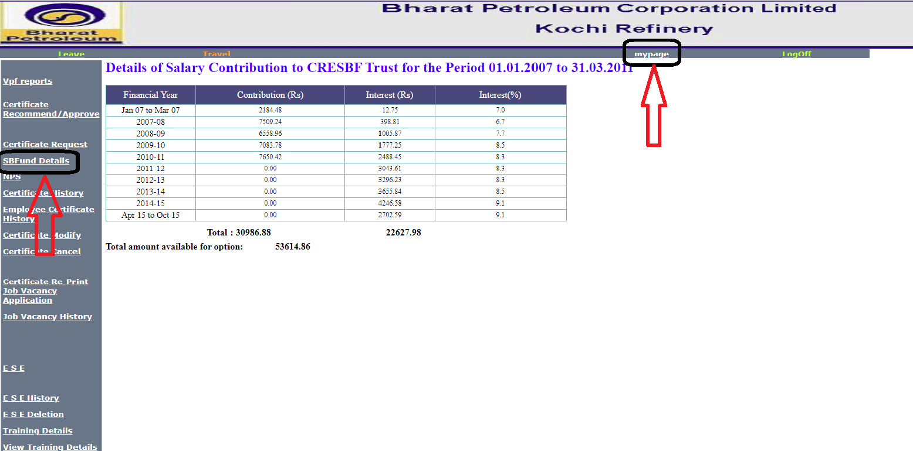

**NPS:-**

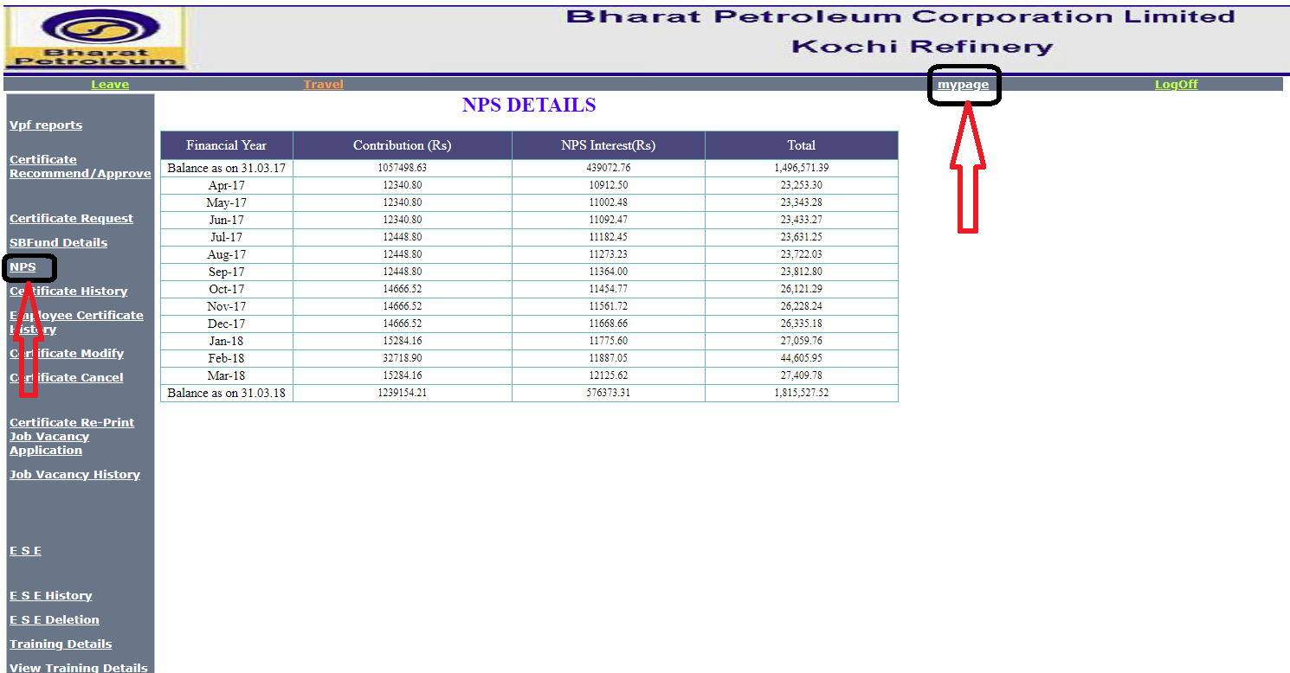

**Certificate History:-**

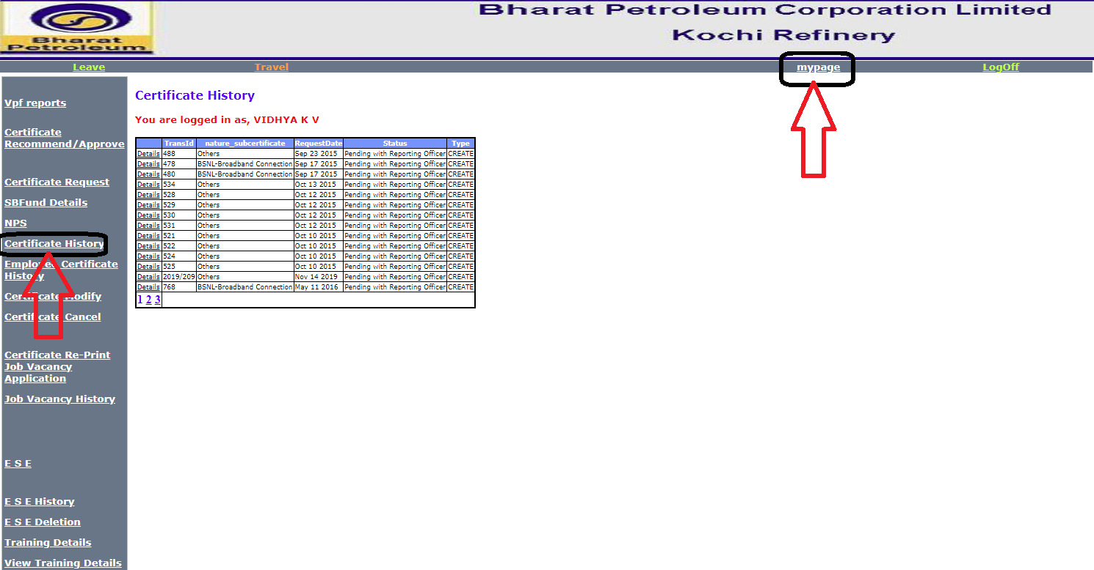

**Employee Certificate History:-**

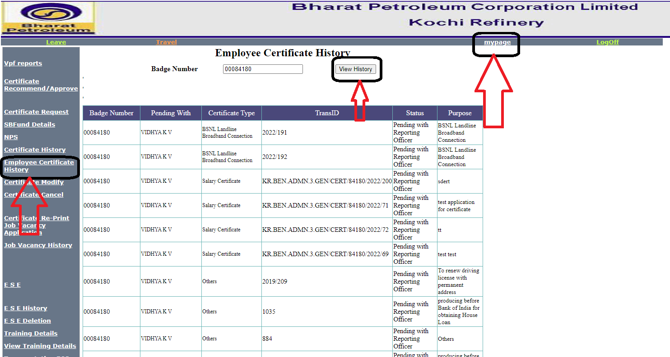

**Certificate Modification:-**

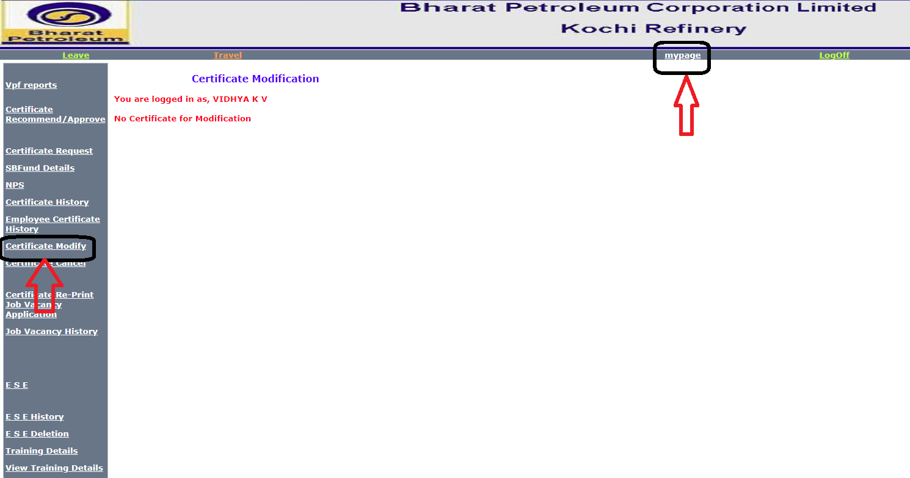

**Certificate Cancellation:-**

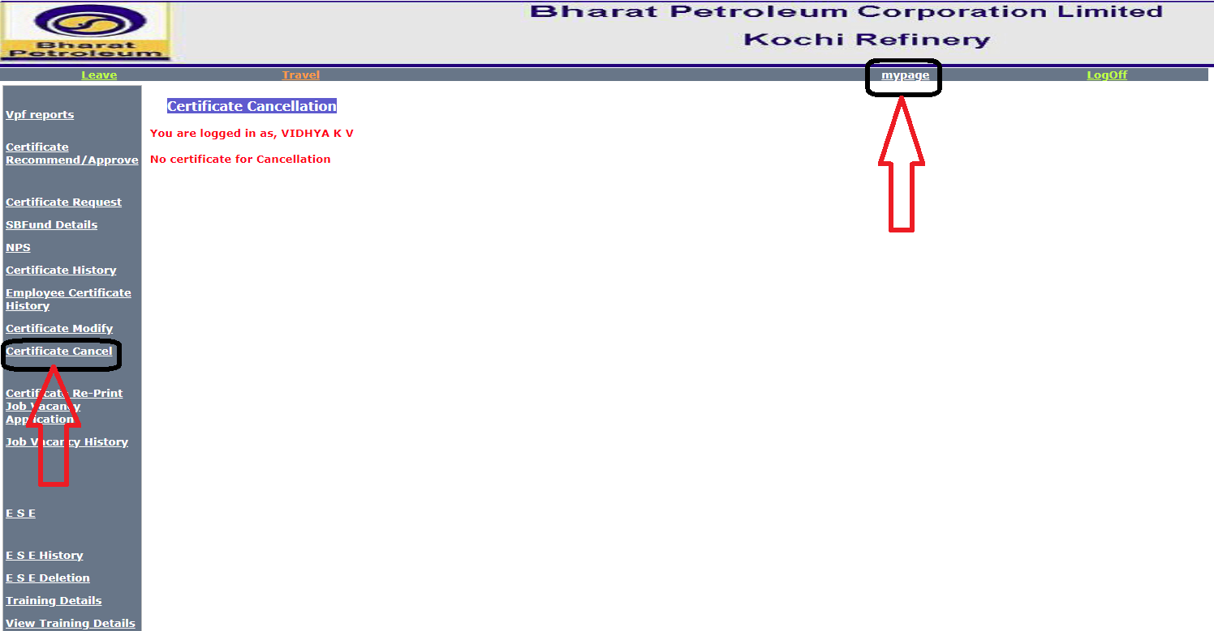

[**Certificate Re-Print**](http://kdcvgaweb07p/ess/Aspx/Copy%20of%20CertificatePrint.aspx)[**Job Vacancy Application**](http://kdcvgaweb07p/ess/Aspx/AppReq1.aspx):-

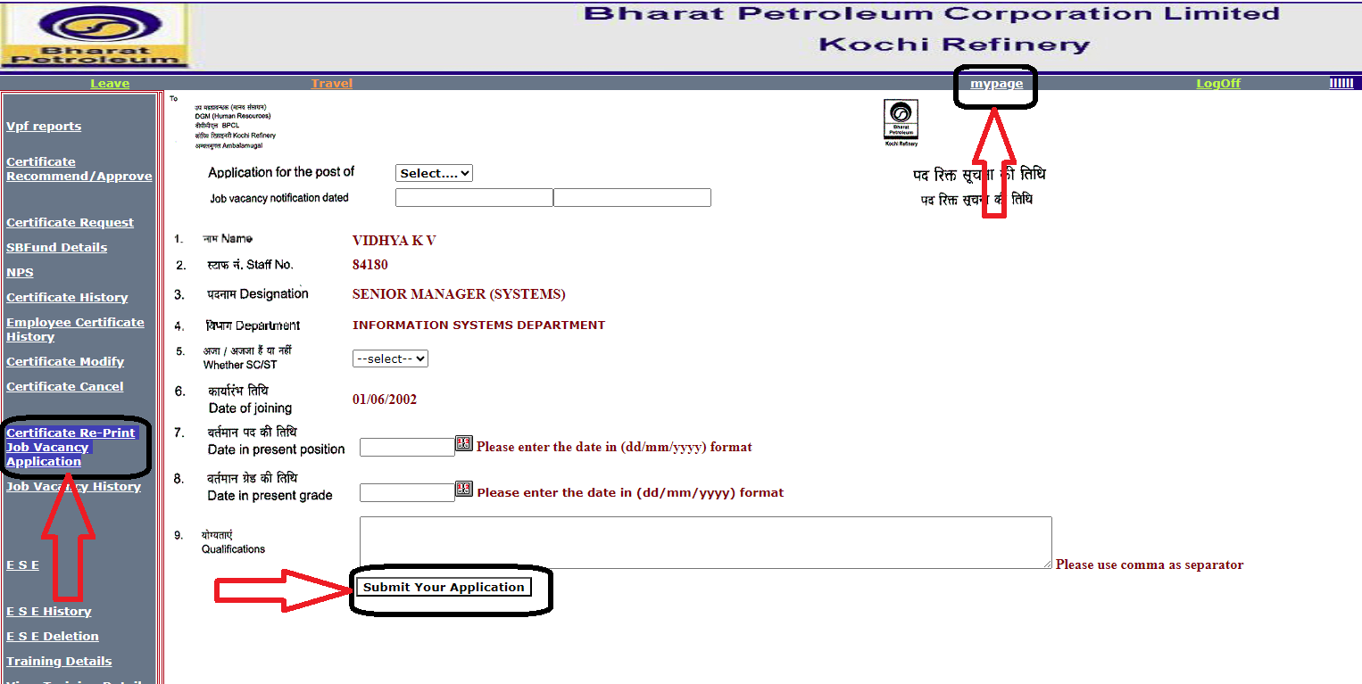

[**Job Vacancy History**](http://kdcvgaweb07p/ess/Aspx/aphist.aspx):-

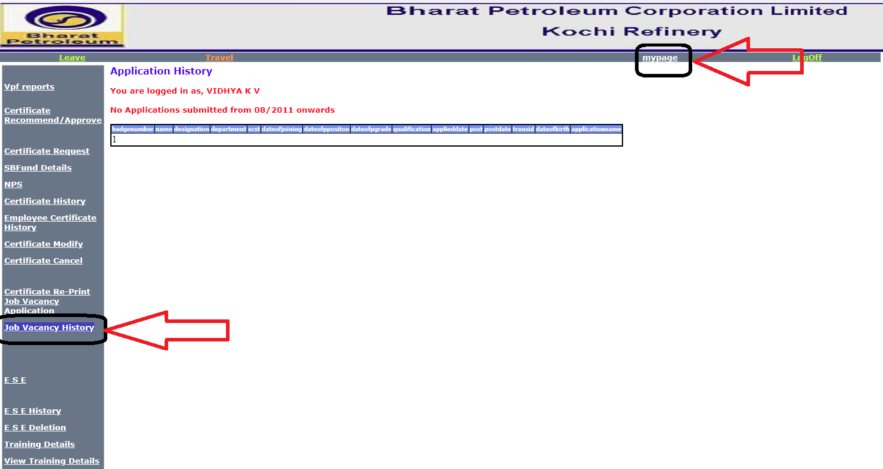

**Employee Satisfaction Enhancement Cell:-**

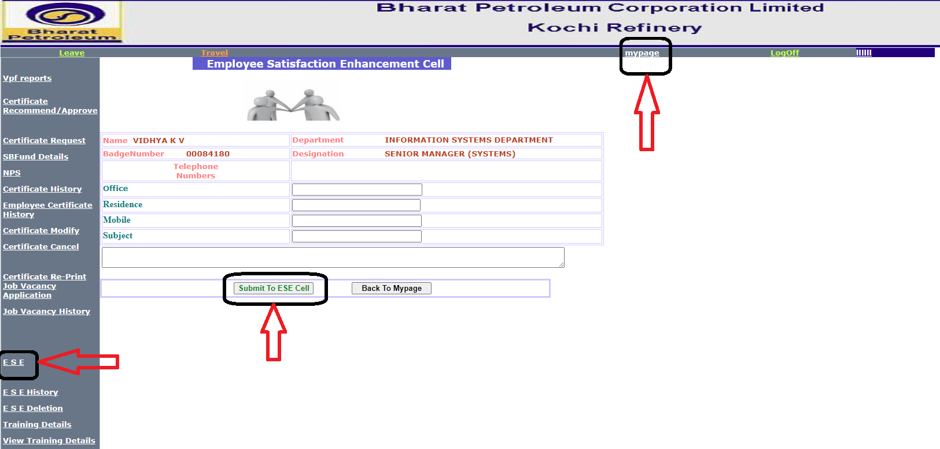

**Employee Satisfaction Enhancement Cell History:-**

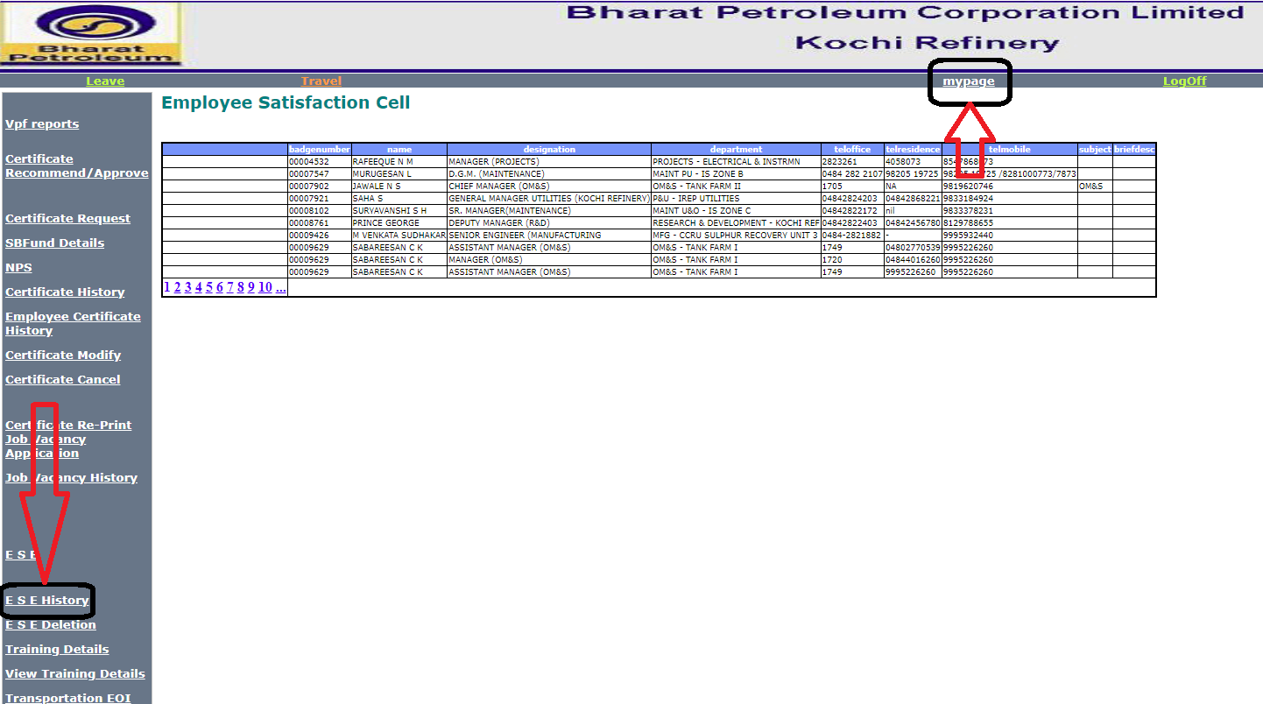

**Deletion of ESE Entries:-**

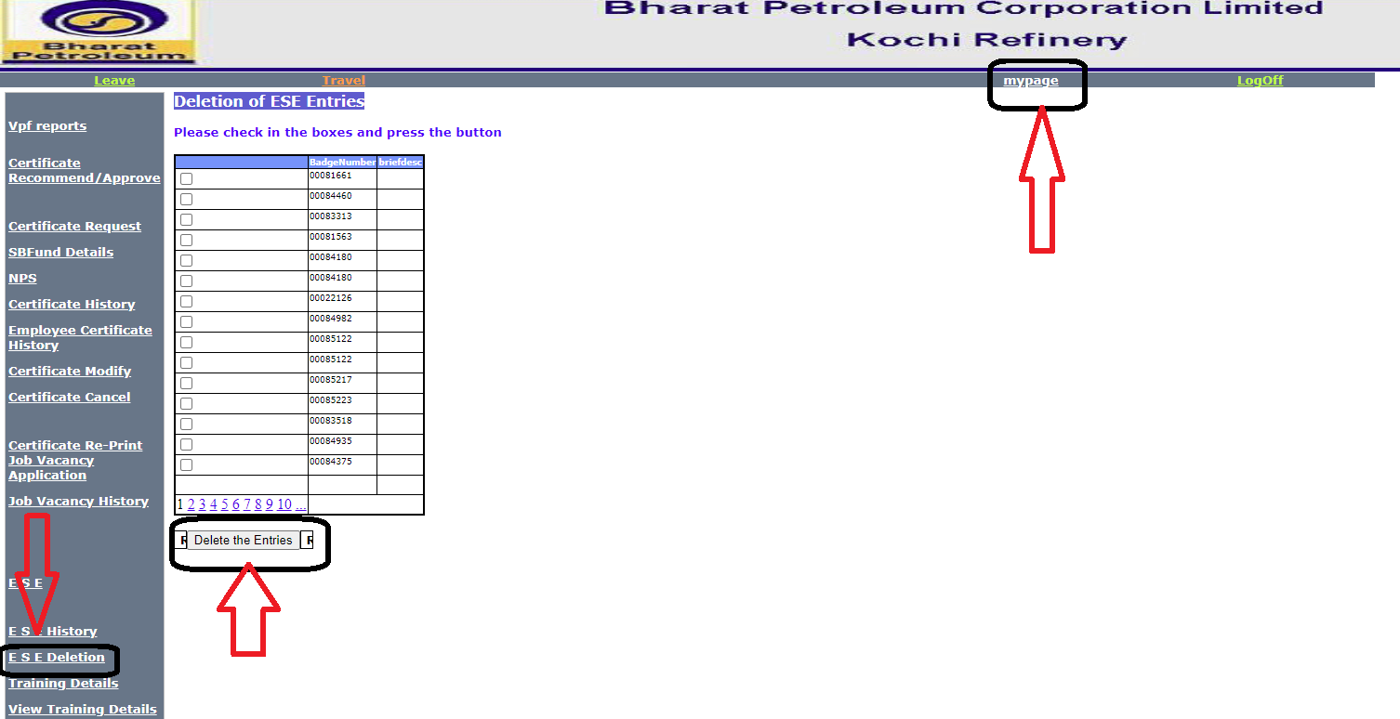

**Training Details:-**

